|  |
| --- |
| **IS2150 E-Business Design and Implementation** School of Computing National University of Singapore |
| Macintosh HD:Users:user:Downloads:is2150 designs:logos:is2150 logo_3.png |
| **Business Plan**  Ho Ren Sen (A0111860R) Jin Wenqian (A0105484H) Nguyen Tran Nhat Uyen (A0119323M) Zhang Zhixuan (A0124493E) |
| **6 March 2016**  Academic Year 2015/2016 Semester 2 |

Table of Contents

SECTION 1. Business Overview 1

SECTION 2. Value Propositions 2

2.1. No home or family presence required 2

2.2. Real-time updates and flexible control at their service 2

2.3. Social sharing with neighbours 3

2.4. Partnership with Airbnb for short-term laundry needs 3

2.5. Price-saving and hygienic cleaning innovation 3

2.6. Best hygiene for small household units 3

SECTION 3. Revenue Model 4

3.1. Subscription fee 4

3.2. One-time service fee 4

SECTION 4. Competitive Environment 5

SECTION 5. Competitive Advantage 6

SECTION 6. Organic Marketing and Advertising Strategies 7

6.1. Volume discount 7

6.2. Email direct marketing 7

6.3. Social sign-on 8

6.4. Referral campaign 8

6.5. Collaborative Shopping (Box sharing) 8

6.6. Facebook App 9

SECTION 7. Sitemap 10

SECTION 8. Features 12

8.1. User account management 12

8.2. Product management 13

8.3. Customer support 13

8.4. Invoicing management 13

8.5. Laundry orders management 14

SECTION 9. Data model 16

SECTION 10. Subsystem Design 18

# Business Overview

LaundryButler is a professional full-fledged laundry pickup and delivery service in Singapore, which aims to solve busy professionals and students’ laundry woes during their working hours using technology-enabled innovation. It also aims to disrupt the ineffective laundry retail services that need to operate overtime for busy customers after office hours.

LaundryButler uses internet technology to receive and fulfil laundry orders efficiently, while customers can make ad-hoc laundry requests or subscribe to regular laundry services. Customers register for their accounts and may purchase a subscription plan and/or ad-hoc service. Prior to the first pickup, customers will be given their first box, a randomly generated passcode sent electronically, and a physical passcode lock to lock their identifiable boxes against their doors or nearby corridors. Vehicles and drivers will then be dispatched to unlock and collect the customer boxes, sending them to the washing units and finally delivering to the customers’ homes, ready for the next business cycle.

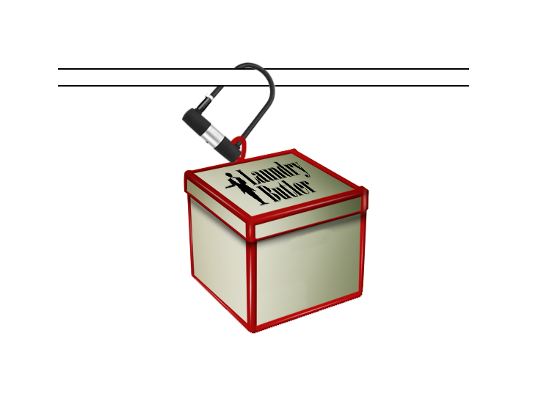

Figure 1: Illustration of LaundryButler box hanged at a balcony with lock

To grow the business organically, new customer channels will be opened online such as Facebook, innovative customer relationships will be created such as collaborative shopping, and dynamic incentives will be enabled by the website such as referral benefits.

# Value Propositions

Laundry is a tedious and time-consuming task for busy professionals and students, small flat residents, and accidental customers such as travellers. On the other hand, laundry retail outlets would usually operate overtime to meet the needs of customers during non-office hours. For these highly independent customers who value time and quality hygiene, the basic process of washing and drying would get into the momentum of their lives, let alone the overwhelming prospect of walking into a professional retail outlet.

LaundryButler’s overall mission is to provide an effortless laundry experience for customers so that they can use the time saved for other important matters. This mission will be achieved with the following value propositions.

## No home or family presence required

Many delivery services required customers to be present because they need to sign and acknowledge physically the receipt of an item or service. However, this is not always convenient for customers. LaundryButler do not require customers to be present at home, because the boxes containing the customers’ clean or dirty clothes will be physically secured near their doorsteps, thus giving them convenience and time to focus on their work. There is also no notion of self-pickup by the customers.

## Real-time updates and flexible control at their service

LaundryButler empowers customers with a two-way feedback system to increase customer satisfaction. In addition to scheduling, managing and tracking their laundry orders via the website, they may allow LaundryButler to send order status updates (i.e. “picked up”, “cleaned”, “delivered”). Customers will also be encouraged to rate the completed laundry service.

## Social sharing with neighbours

Customers may willingly share and combine their laundry loads with people staying nearby to maximize the value of their subscription.

## Partnership with Airbnb for short-term laundry needs

In addition to the homes of the customers, they as guests can request for ad-hoc laundry services through Airbnb. The address of the host will be used in the order.

## Price-saving and hygienic cleaning innovation

LaundryButler uses biodegradable laundry solutions to avoid depositing leftover fillers or residues (from otherwise nonbiodegradable liquids) in the clothes that may cause itchiness or skin allergies, thus giving the customers the best hygiene and original clothing quality they deserve. Although the premium solutions are slightly costly, the significantly reduced cost of machine maintenance will be passed to customers as low-priced service.

## Best hygiene for small household units

Families in small households tend to turn to their personal spaces such as living rooms to hang and dry additional clothes, which is unhygienic. An option for these customers is to “outsource their spaces” to LaundryButler for drying; let the business take care of their drying needs.

# Revenue Model

LaundryButler makes money through customer orders. These customers will be automatically charged via their credit cards or alternative payment methods on file. The revenue collected from the business will be used to cover fixed costs such as laundry equipment and technology infrastructure, and variable costs such as marketing activities, labour and laundry supply replenishment.

## Subscription fee

For any plan below, customers will be given a free laundry box that can hold up to 8 kg of clothes. The clothes are washed and ironed normally

|  |  |  |  |
| --- | --- | --- | --- |
|  | Plan A | Plan B | Plan C |
| Price | $32.00 / week | $28.00 / week | $25.00 / week |
| Duration | 12 weeks | 24 weeks | 48 weeks |

## One-time service fee

Both our recurring customer and one-time customers (such as guests from Airbnb homes) can purchase additional services.

|  |  |
| --- | --- |
| Express service (delivered within 6 hours) | Add $10.00 per box |
| Dry wash | $6.00 / piece |
| Ad-hoc laundry service (the box also holds up to 8 kg) | $35.00 / box |

# Competitive Environment

The current major competitors include My Laundry Box, Just Relax and Cotton Care. These services also provide home pickup and delivery. The competitive landscape was scanned using the Porter’s Five Forces Model.

|  |  |  |
| --- | --- | --- |
| Force | Remarks | Pressure |
| Rivalry among existing competitors | * My Laundry Box is the most recent competitor in the jaded laundry industry in Singapore * Relatively many competitors offering similar services in the market but not enabled by technology | Medium |
| Bargaining power of buyers | * Many families in Singapore own washing machines but few drying machines * Customers of existing competing solutions are not loyal * Existing laundry retail outlets need to work overtime and self-collection laundry points have high overheads in order to meet 24/7 availability of customers | High |
| Bargaining power of suppliers | * Many cleaning solutions are homogeneous with only a few being biodegradable or organic * Equipment is largely available in the market | Low |
| Threat of new entrants | * High capital requirements such as setup cost * Requires a complex delivery system | Low |
| Threat of substitutes | * Customers may have the option to exchange time with laundry chores * Cost of switching to another store is high if customers have purchased the long-term subscription plan | Medium |

# Competitive Advantage

The most innovative competitive advantage is that customers are not required to be present at home, made possible by online orders and offline security measures. This gives the customers greater flexibility and control over their own schedule.

Another point worth noting is that all current players require customers to call, text or email the store to order for laundry service, which has longer latency than real-time notifications. In addition, notifications allow customers to follow up with a sense of confidence and security transparently, which is not available by other forms of communication. LaundryButler will thus be the first to allow customers to make orders online and enjoy an effortless out-of-home experience.

Furthermore, unlike our competitors, LaundryButler is differentiated in the following ways:

* Laundry box sharing helps increase consumer benefits. It is common that some customers may not use up all the space allowable in their box, hence not maximising their subscription fee and decrease efficiency. This also creates a greater sense of community among our users.
* Airbnb guests can use ad-hoc service during their stay in Singapore.

# Organic Marketing and Advertising Strategies

## Volume discount

LaundryButler incorporates volume discount in its pricing scheme. The base price is $35 per box for ad-hoc laundry requests. If the customers choose to sign up for a long-term plan, i.e. the 12-week, 24-week and 48-week plan, they would be given a discount of 90%, 80% and 70% accordingly on the total amount payable.

The volume discount pricing scheme is an up-selling strategy that would incentives customers to opt-in for the longer and larger subscriptions. Once transacted, customers are locked-in for the service for a long period of time. The lock-in strategy prevents the customers from switching to competitors’ service and develop brand loyalty for LaundryButler in the long run.

## Email direct marketing

Users are required to use their email address to register for an account with LaundryButler, and they would receive transactional records through the email. Besides, LaundryButler will send newsletter or other marketing emails to users who opt-in for them.

With the email direct marketing (EDM), LaundryButler is able to implement drip campaigns for its users. It’s a pre-written lifecycle email campaign that is sent out automatically according to a predetermined schedule. The messages are dripped often in a series applicable to a specific behavior or status of the recipient, or at different stages of their customer journey with LaundryButler. Besides, LaundryButler is able to send out other ad-hoc marketing materials such as seasonal discounts.

## Social sign-on

Facebook is the most popular social network at this age and every business wants to leverage on the power to social marketing with Facebook, so does LaundryButler. We implement Social Sign On with Facebook. When signing up with LaundryButler, users can choose to link their Facebook accounts with their LaundryButler accounts and log in with them. This allows LaundryButler to access their information from their Facebook account and subsequently use the data for marketing purpose. For example, we can set up Custom Audience and Lookalike display campaigns on Facebook using the users’ demographic information to expose marketing materials to people who are like them.

## Referral campaign

When completing a laundry task, users are able to share their experience on LaundryButler to their Facebook account to invite friends to join the service. The referral links are embedded with identifiable tags and LaundryButler would be able to track the “referrer” and the “referee”. If one of a user’s friend clicked on the link and subsequently signed up with LaundryButler, he and the friend will both be awarded with a free dry cleaning service. This friend who have newly signed up with LaundryButler would likely explore with the service and generate more business with LaundryButler. He can then share his referral link to his friends afterwards. The more friends one shares this link to, the higher chance one could gain more benefits. This referral campaign thus incentivizes user sharing and in turn acquire more users.

## Collaborative shopping (box sharing)

When a user is not able to fill up his laundry box in any week, he can indicate he’s willing to share his box with other users on LaundryButler. Another user who has more clothes for his box would then be able to discover all the available boxes for sharing. He’s able to see all of the available boxes on a map which would help him decide on which one to share with based on the distance. This function provides users with more flexibilities and they would likely to continue their subscriptions with less concern on box size problem.

## Facebook app

LaundryButler has a Facebook App which behaves the same as the original website. It allows customers to manage, order and check their laundry tasks without leaving their Facebook page. If the users allow LaundryButler to share their usage of the Facebook app with their Facebook friends, they can access the Facebook App instantly without going to the website. LaundryButler is also able to use the Facebook platform to send out push notifications to users of the Facebook app so as to bring them back to the service from time to time. The Facebook app can thus help with the LaundryButler’s customer retention immensely.

# Sitemap

|  |  |
| --- | --- |
| **Page** | **Actionable Features and Views** |
| / | * Landing page which contains information about the business, features, pricing plans, contact information, promotional advertisements, newly released plans and call-to-action statements |
| /get-started | * Login by registered Email address and password * Registration (with referrer’s code optionally) * Email verification by one-time code |
| /boxes | * Acts as a dashboard after logging in: View a filtered/paginated list of completed/unscheduled/scheduled laundry tasks with summarised details such as pickup date, delivery date, current status, charge (or promotional charge), physical lock passcode and assigned employee * View task details and actionable items upon expanding a task item such as rating a completed laundry task, allowing a box to be discoverable for sharing, approve or reject a neighbour’s permission to share with paying customer, see whether a free box is gifted by a friend or given by the business through referring benefits |
| /buy | * Add / Edit subscription plans or ad-hoc requests to user’s shopping cart * View cart items with brief information like quantity, pricing, and plan ID * Checkout a shopping cart with selected items * Checkout a shopping cart as a gift for someone else * View available payment methods, Such as PayPal and credit card * Payment for checkout items (or the promotional bundle price) |
| /buy/results | * View whether the transaction is successful * Upon success, the page will redirect to boxes page (dashboard) * Upon failure, the page will redirect to buy page (shopping cart) |
| /profile | * View / Edit first name, last name, default address, alternate addresses, password, gender, date of birth, contact number Facebook ID, and Airbnb ID * View customer ID, email, account status and registration date |
| /payment | * View / Edit PayPal account information or credit card information: cardholder’s name, credit card number, expiry month and expiry year |
| /invite | * Customer can share their completed task on their social media platform as a referrer and his friends can click on the link shown in the post to register as a new user. Both the referrer and referee would receive a free box |
| /logout | * Log out from LaundryButler system and exit to the home page |
| /admin | * Act as a dashboard for administrators * View summary of customers, products, orders and tasks e.g. number of customers, number of tasks |
| /admin/customers | * Search for and view a customer’s profile * Change the information or status in customers’ accounts |
| /admin/products | * View and edit the details of the products (i.e. subscription plans, additional services) |
| /admin/orders | * View each customer’s order details * Process orders to tasks (i.e. 3-month subscription plan equals to 12 tasks) |
| /admin/tasks | * View and update the laundry task status for customers to track the progress |
| /admin/billing | * Email customer’s purchase invoice to customers * View all records of past purchase details |
| /admin/logout | * Log out from LaundryButler system and exit to home page |

# Features

## User account management

|  |  |
| --- | --- |
| **Feature** | **Description** |
| Registration | Customer registration as a new customer. Information required: email\_address (Primary key), password, username, gender, address, contact\_number, isAirbnb (if possible) |
| Activation of user account | After registration, an email will be sent to registered Email address, upon clicking the link specified in the Email, user account will be activated and verified. |
| Login/Logout | Logging into LaundryButler system by using verified Email address and password. |
| View/Edit account information | User could edit their own account profile and update their information |
| View order history | View past order record detail (i.e. purchase date, purchase total price, number of products and payment method) |

## Product management

|  |  |
| --- | --- |
| **Feature** | **Description** |
| CRUD product information detail | All ad-hoc, additional services and plans are categorized as products. CRUD product detail, such as product\_id, description, price and last update time |

## Customer support

|  |  |
| --- | --- |
| **Feature** | **Description** |
| Enquiry submission | User can submit their enquires as a form of email to system admin, each enquires can be either anonymous or sign off with user’s ID |
| Enquiry processing | Admin will reply / answer user’s enquiries by LaundryButler admin Email address |

## Invoicing management

|  |  |
| --- | --- |
| **Feature** | **Description** |
| Emailing of invoice | System will email customers’ purchase invoice at the end of each month |
| View invoice history | Admin account user could view all past purchase invoices in the admin dashboard |

## Laundry orders management

|  |  |
| --- | --- |
| **Feature** | **Description** |
| View subscription plans and ad-hoc services | Customers could view all types of services in detail on the page |
| Add product into cart | Use “add to cart” button provided below each individual product to add the product into users’ shopping cart |
| View/Edit cart items | User can change the number of orders specified or delete any items in the cart |
| Checkout for cart items | User can checkout their cart items and direct to a third party payment website to complete their payments |
| User shares a completed task on Facebook | User may share a completed laundry task on Facebook and use it as a referral to attract new user. An incentive will be given for both referrer and referee. |
| User logs into LaundryButler via Airbnb | Airbnb user may log into LaundryButler via their Airbnb account and complete their order requirement when they book for an Airbnb room. |
| User may enable their boxes discoverable and sharable | LaundryBulter will read user address and the user will be able to enable the sharing of their boxes to their neighbours. User could also accept or deny others sharing request. |
| User can gift boxes to other customers | User could purchase orders and send as a gift to their family members or friends. |
| System deposit bonuses to both referees and referrer | A customer may refer a friend to sign up as a new user of LaundryButler through a referral link. This referral link contains an identifiable information about the referrer. The link will send the new user to the signup page where it will automatically insert the referrer’s identifiable information, so that the system can recognize the pair of referee and referrer whom deserve a complementary laundry box. |

# Data model

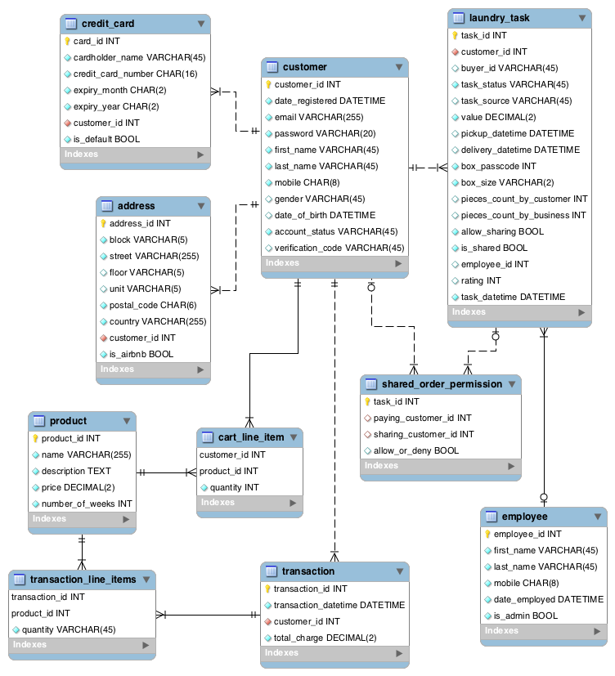

|  |  |
| --- | --- |
| **Table** | **Description** |
| customer | * Used for account registration and verification * Used for authentication * Users may also update their profile information * Accounts may also be managed by administrators |
| credit\_card | * Users may hold more than one credit card on file |
| address | * Users may hold more than one address on file * Each address may come from Airbnb as a current guest |
| product | * Admins may change or introduce new pricing plans and ad-hoc services |
| cart\_line\_item | * Acts like a shopping cart which all selected plans and/or ad-hoc services will be moved to “transaction\_line\_item” after successful checkout |
| laundry\_task | * Also implies a box * Status of the task is progressively updated * An unscheduled task will have no pickup and delivery dates; they are created as a result of someone gifting to them or LaundryButler giving a complimentary box * A scheduled task will have pickup and delivery dates, assigned employee name, box passcode and a charge (or promotional charge); they are created as a result of a self-purchase or requested through Airbnb * Ratings can only be filled in when a task is completed * Sharing on Facebook is enabled when a task is completed * Each box (i.e. laundry task) may be made discoverable by others |
| shared\_order\_permission | * A paying customer can approve or deny a neighbour’s permission to share a laundry box |
| employee | * Each employee may be responsible for one or more “laundry\_task”s |
| transaction | * Each transaction holds one or more “transaction\_line\_item”s |
| transaction\_line\_item | * Each line item contains the quantity of the particular plan or ad-hoc service |

# Subsystem Design

|  |  |  |  |  |
| --- | --- | --- | --- | --- |
| Subsystem | Module | Functionality | Description | User |
| User Account Management | User and Purchase History | Register as member | Register as member | Customers |
| Activate account | Activate account before usage | Customers |
| Login | Login to dashboard | Customers |
| Logout | Logout from LaundryButler | Customers |
| View/Edit account information | Display/Edit own account information | Customers |
| View order history | View past order record | Customers |
| Suspend account | Suspend a user's account | Admin |
| Product Management | Product | CRUD subscription plans | CRUD a subscription plan | Admin |
| Laundry Orders Management | Purchasing | View subscription plans and ad-hoc services | View the specific details of each subscription plan or ad-hoc service | Customers |
| Add product or ad-hoc item to cart | Add subscription plan and ad-hoc service to shopping cart | Customers |
| View cart items | View cart items | Customers |
| Check out items | Check out items | Customers |
| Box Sharing | Allow box sharing | Turn on box sharing permission and shows phone numbers to other users | Customers |
| Discover nearby users | Discover nearby users to share laundry box with | Customers |
| Request for box sharing | Request another user to allow you to share box | Customers |
| Allow / Deny sharing request | Allow / Deny box sharing request by another user | Customers |
| Social Sharing | Share on Facebook | Share completed laundry task on social media channels | Customers |
| Gifting | Purchase product as gift | User can purchase plan/product as a gift | Customers |
| Referral | Generate referral link | Every social sharing link are embedded with tracking token | System |
| Share referral link | User can share their referral link on social media | Customers |
| Track referral with new sign-ups | System should track the source referrer when a new sign-up happens | System |
| Attribute credits with new sign-ups | System will attribute credits accordingly when a new sign-up happens through referral links | System |
| Task Management and Tracking | Generate passcode | Generate 1st passcode for laundry box lock | Admin |
| Assign employee to a task | Assign employee to a task | Admin |
| Send SMS for status update | Send SMS when collecting and dropping box | Admin |
| Send browser notifications for order status update | Browser notifications of order status when collecting and dropping box | Admin |
| Track status of laundry order | Track status of laundry order | Customers |
| Third-party partnership | Request for laundry from current Airbnb stay | Gets the current address of the Airbnb guest and creates a laundry order using that address | Customers |
| Invoice Management | Invoice Management | Email invoice | Email invoice to users | Admin |
| View invoice history | View invoice history | Customers |
| Customer Support | Email Support | Submits enquiry | Submit enquiry online | Customers |
| Process enquiry | Process enquiry and send reply | Admin |